***A***

***SYNOPSIS ON***

***CORONAVIRUS OUTBREAK ANALYSIS AND PREDICTION***

***SUBMITTED BY :-***

***~GOURAV RANA***

***……………………………………………………………………………………………………………….... SUBMITTED IN FULFILLMENT OF THE REQUIREMENT FOR MAJOR PROJECT SUBMISSION***





***TABLE OF CONTENTS~***

# INTRODUCTION

➢

# OBJECTIVES

* ***SOFTWARE & HARDWARE REQUIREMENT***

# METHODOLOGY TO BE USED

* ***CONCLUSION***

# GROUP MEMBER DETAILS

## INTRODUCTION

*The novel*[*coronavirus*](https://www.sciencedirect.com/topics/biochemistry-genetics-and-molecular-biology/coronavirinae)*disease initiated in late 2019 (COVID-19) results from the infection with the severe acute respiratory syndrome-coronavirus 2 (SARS-CoV-2). Since late 2019, it has spread globally, leading to a persistent pandemic. COVID-19 spread is dependent on inter-individual close contacts and transmission of breath droplets. Prediction of the rate of COVID-19 spread and modeling of its course have a critical impact not only for health systems but also for policymakers. In fact, policy making relies on discernments formed by prediction models to propose new strategies and to measure the efficiency of the imposed policies. Based on the nonlinear and complex nature of this disorder application of artificial intelligence methods is an appropriate alternative to traditional epidemic models for prediction of its spread. Although some traditional epidemic models such as Susceptible-Exposed-Infective-Recovery has been used for prediction of epidemic course , these methods have some limitations. For instance, the validity of the Susceptible-Exposed-Infective-Recovery model relies on precise appraisal of virus transmission features including the basic reproductive quantity R0 as well as incubation and*[*infectious periods*](https://www.sciencedirect.com/topics/mathematics/infectious-period)*which are rather difficult to be estimated in real contexts .*



## OBJECTIVE OF THE PROJECT

*The objectives of this project is to predict and analyse the outbreak of COVID-19 in various states of India.*

## Introduction to machine learning

*According to Arthur Samuel (1959), ML is the field of study that gives computers the ability to learn without being explicitly programmed. Thus, we can define ML as the field of computer science in which machines can be designed that can program themselves.*

*The process of learning is simply learning from experience or observations from previous work, such as examples, or instruction, to look for patterns in data and with the help of examples, provided the system can make better decisions. The basic aim of ML is to make computers learn automatically with no human intervention and to adjust perform actions accordingly.*

*Past data are used to train the model, and then this trained model is used to test new data and then for prediction. The trained ML model's performance is evaluated using some portion of available past data (which is not present during training). This is usually referred as the validation process. In this process, the ML model is evaluated for its performance measure, such as accuracy. Accuracy describes the ML model's performance over unseen data in terms of the ratio of the number of correctly predicted features and total available features to be predicted.*

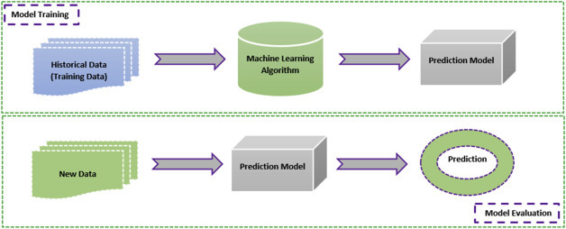

### ***Some machine learning methods***

*ML algorithms can be divided into supervised or unsupervised learning:*

* *Supervised ML algorithms is a type of ML technique that can be applied according to what was previously learned to get new data using labeled data and to predict future events or labels. In this type of learning, supervisor (labels) is present to guide or correct. For this first analysis, the known training set and then the output values are predicted using the learning algorithm. The output defined by the learning system can be compared with the actual output; if errors are identified, they can be rectified and the model can be modified accordingly .*
* *Unsupervised ML algorithms: In this type, there is no supervisor to guide or correct. This type of learning algorithm is used when unlabeled or unclassified information is present to train the system. The system does not define the correct output, but it explores the data in such a way that it can draw inferences (rules) from datasets and can describe hidden structures from unlabeled data.*
* *Reinforcement ML algorithms is a type of learning method that gives rewards or punishment on the basis of the work performed by the system. If we train the system to perform a certain task and it fails to do that, the system might be punished; if it performs perfectly, it will be rewarded. It typically works on 0 and 1, in which 0 indicates a punishment and 1 indicates a reward.*

## Use of machine learning in COVID-19

*ML is used in various fields, including medicine to predict disease and forecast its outcome. In medicine, the right diagnosis and the right time are the keys to successful treatment. If the treatment has a high error rate, it may cause several deaths. Therefore, researchers have started using artificial intelligence applications for medical treatment. The task is complicated because the researchers have to choose the right tool: it is a matter of life or death .*

*For this task, ML achieved a milestone in the field of health care. ML techniques are used to interpret and analyze large datasets and predict their output. These ML tools were used to identify the symptoms of disease and classify samples into treatment groups. ML helps hospitals to maintain administrative processes and treat infectious disease .*

*ML techniques were previously used to treat cancer, pneumonia, diabetes, Parkinson disease, arthritis, neuromuscular disorders, and many more diseases; they give more than 90% accurate results in prediction and forecasting .*

*The pandemic disease known as COVID-19 is a deadly virus that has cost the lives of many people all over the world. There is no treatment for this virus. ML techniques have been used to predict whether patients are infected by the virus based on symptoms defined by WHO and CDC .*

*ML is also used to diagnose the disease based on x-ray images. For instance, chest images of patients can be used to detect whether a patient is infected with COVID-19 .*

*Moreover, social distancing can be monitored by ML; with the help of this approach, we can keep ourselves safe from COVID-19 .*

## 5. Different techniques for prediction and forecasting

*Various ML techniques are used to predict and forecast future events. Some ML techniques used for prediction are support vector machine, linear regression, logistic regression, naive Bayes, decision trees (random forest and ETC), K-nearest neighbor, and neural networks (multilayer perceptron) .*

## SYSTEM SPECIFICATIONS

*Software Engineers have been trying various tools, methods and procedures to control the process of software development in order to build high quality software with high productivity. This method provides how it is for building the software while the tools provide automated or semi automated support for the methods. They are used in all stages of software development process, namely, planning, analysis, design, development and maintenance. The software*

*development procedure integrates the methods and tools together and enables rational and timely development of the software system.*

***OLD SYSTEM***

*By doing manually on paper~*

*By doing manually prediction and analysis has been a major issue in sectors like Health and many others. Due to the increase in different types of diseases through different sources, such as Viruses, Blood Pressure, Heart, Aids, etc., Death rate have also increased.*

*Moreover, Prediction and analysis have become very hard in finding escapes so that they can predict next outbreak . Since no system is perfect and there is always a loophole them, it has become a challenging task to make a secure system for Prediction and Analysis*

## How does a Machine Learning system work for Corona virus prediction?

*The below picture shows the basic structure of the working of prediction algorithms using Machine Learning:*

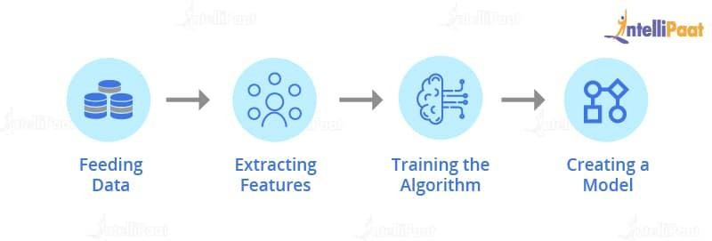

## TECHNOLOGY USED:-

*Language ~ Python*

*Libraries ~ Numpy, Pandas,*

## SYSTEM REQUIREMENT:-

*Minimum ram - 256 MB Hard disk - 40*

*Processor - Intel Pentium 4*

## CONCLUSION:-

*These forecasts are just built on past trends of COVID-19 spread, so forecast values are not definite. Nevertheless, these predicted estimates of events can assist authorities to establish resource planning for better management of this pandemic. Moreover, these methods can be used for prediction of need for preventive measures in each*[*geographical region*](https://www.sciencedirect.com/topics/computer-science/geographical-region)*, thus helping vaccine manufacturers for designing appropriate plans.*

## GROUP MEMBER DETAILS:~

Member 1;

Name- Gourav Rana Ph no- +917015208168

E-mail- [gourav.rana70000@gmail.com](mailto:gourav.rana70000@gmail.com)